SHRAVYA : A Cognitive Ear Worn Assistant with on-board AI Companion

USER MANUAL :- Complete First-Time User Setup Guide
Index
OVERVIEW | PAGE NO. 2
SYSTEM ARCHITECTURE | PAGE NO. 3-4
DATA FLOW | PAGE NO. 5
PRE-REQUISITIES | PAGE NO. 5-6
n8n WORKFLOW SETUP | PAGE NO. 6-12
HARDWARE INTEGRATION | PAGE NO. 13
FRONTEND INTERFACE | PAGE NO. 14-16
TESTING & VALIDATION | PAGE NO. 16-17
PERFORMANCE VALIDATION | PAGE NO. 17
DEBUG MODE | PAGE NO. 18
SECURITY CONSIDERATION | PAGE NO. 19
CONCLUSION | PAGE NO. 20

OVERVIEW

SHRAVYA (She Hears, Responds and Attends to Your Awareness) is a cognitive ear-worn AI assistant that combines real-time EEG processing with intelligent cloud-based AI agents. The system consists of:
- Hardware: Renesas EK-RA8D1 MCU with ADS1263 ADC for EEG acquisition
- Firmware: μT-Kernel 3.0 RTOS with real-time signal processing and AI inference
- Cloud/Self-Hosted Platform: N8N workflow automation with multi-agent AI system
- Frontend: Web-based interface for monitoring and interaction
- Database: MongoDB for EEG data storage.
Key Features
- Real-time EEG signal processing (2000 SPS, 32-bit ADC)
- On-chip neural network inference (sub-100ms latency)
- 6 cognitive state classification (Focus, Stress, Anxiety, Fatigue, Calm, Flow)
- Multi-modal feedback (haptic, voice, visual)
- Voice command processing with natural language understanding
- Cloud analytics and trend analysis

SYSTEM ARCHITECTURE

1) The SHRAVYA system follows a multi-tier architecture :-
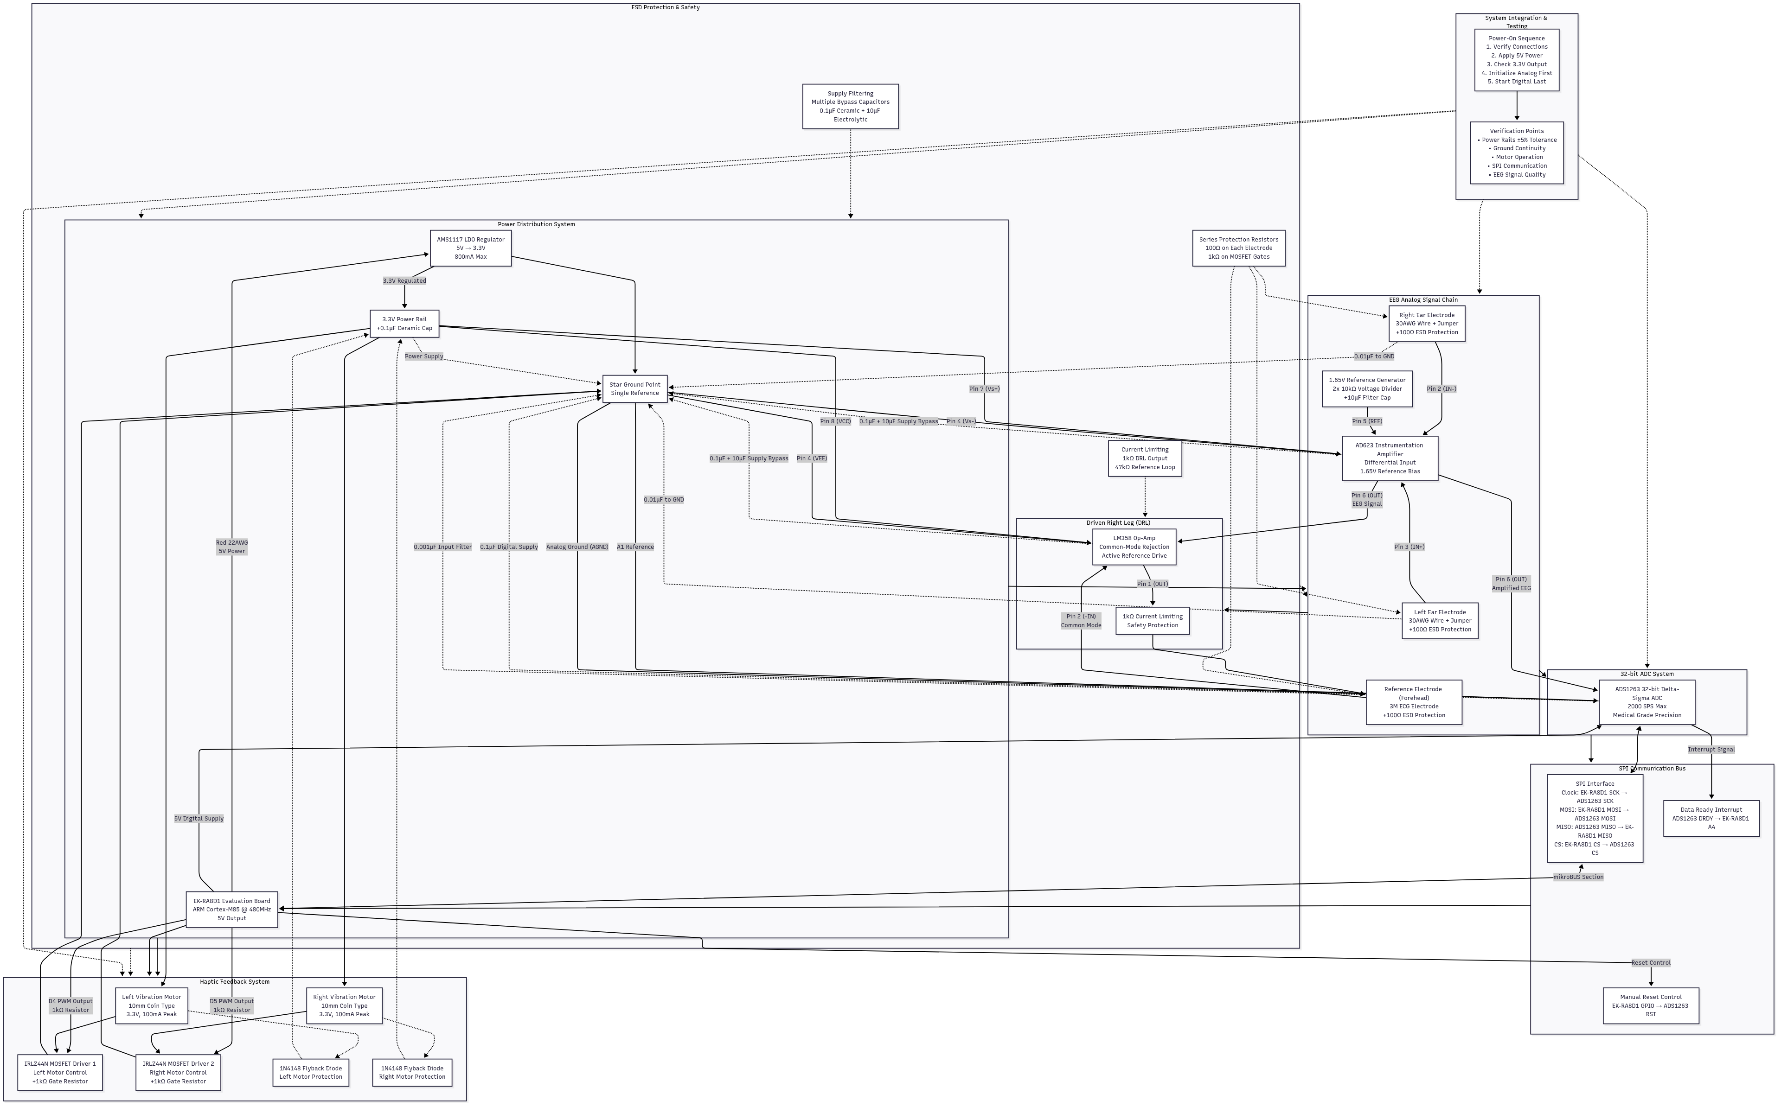
2) Component Level Flowchart :-
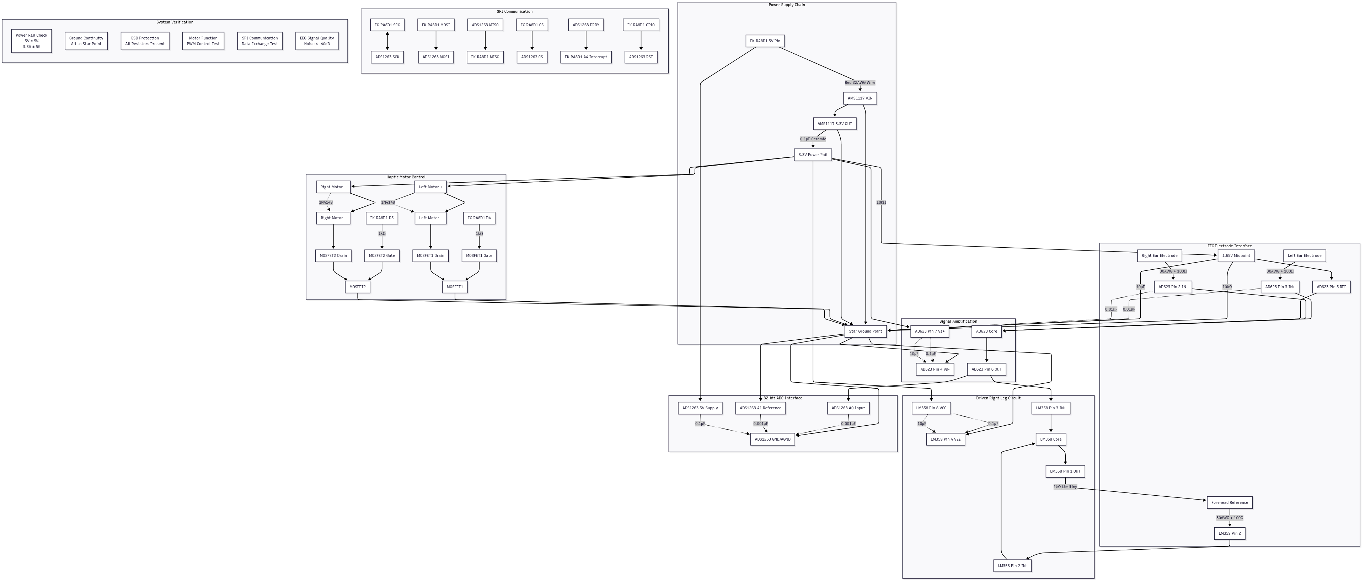
3) High Level System Overview :-
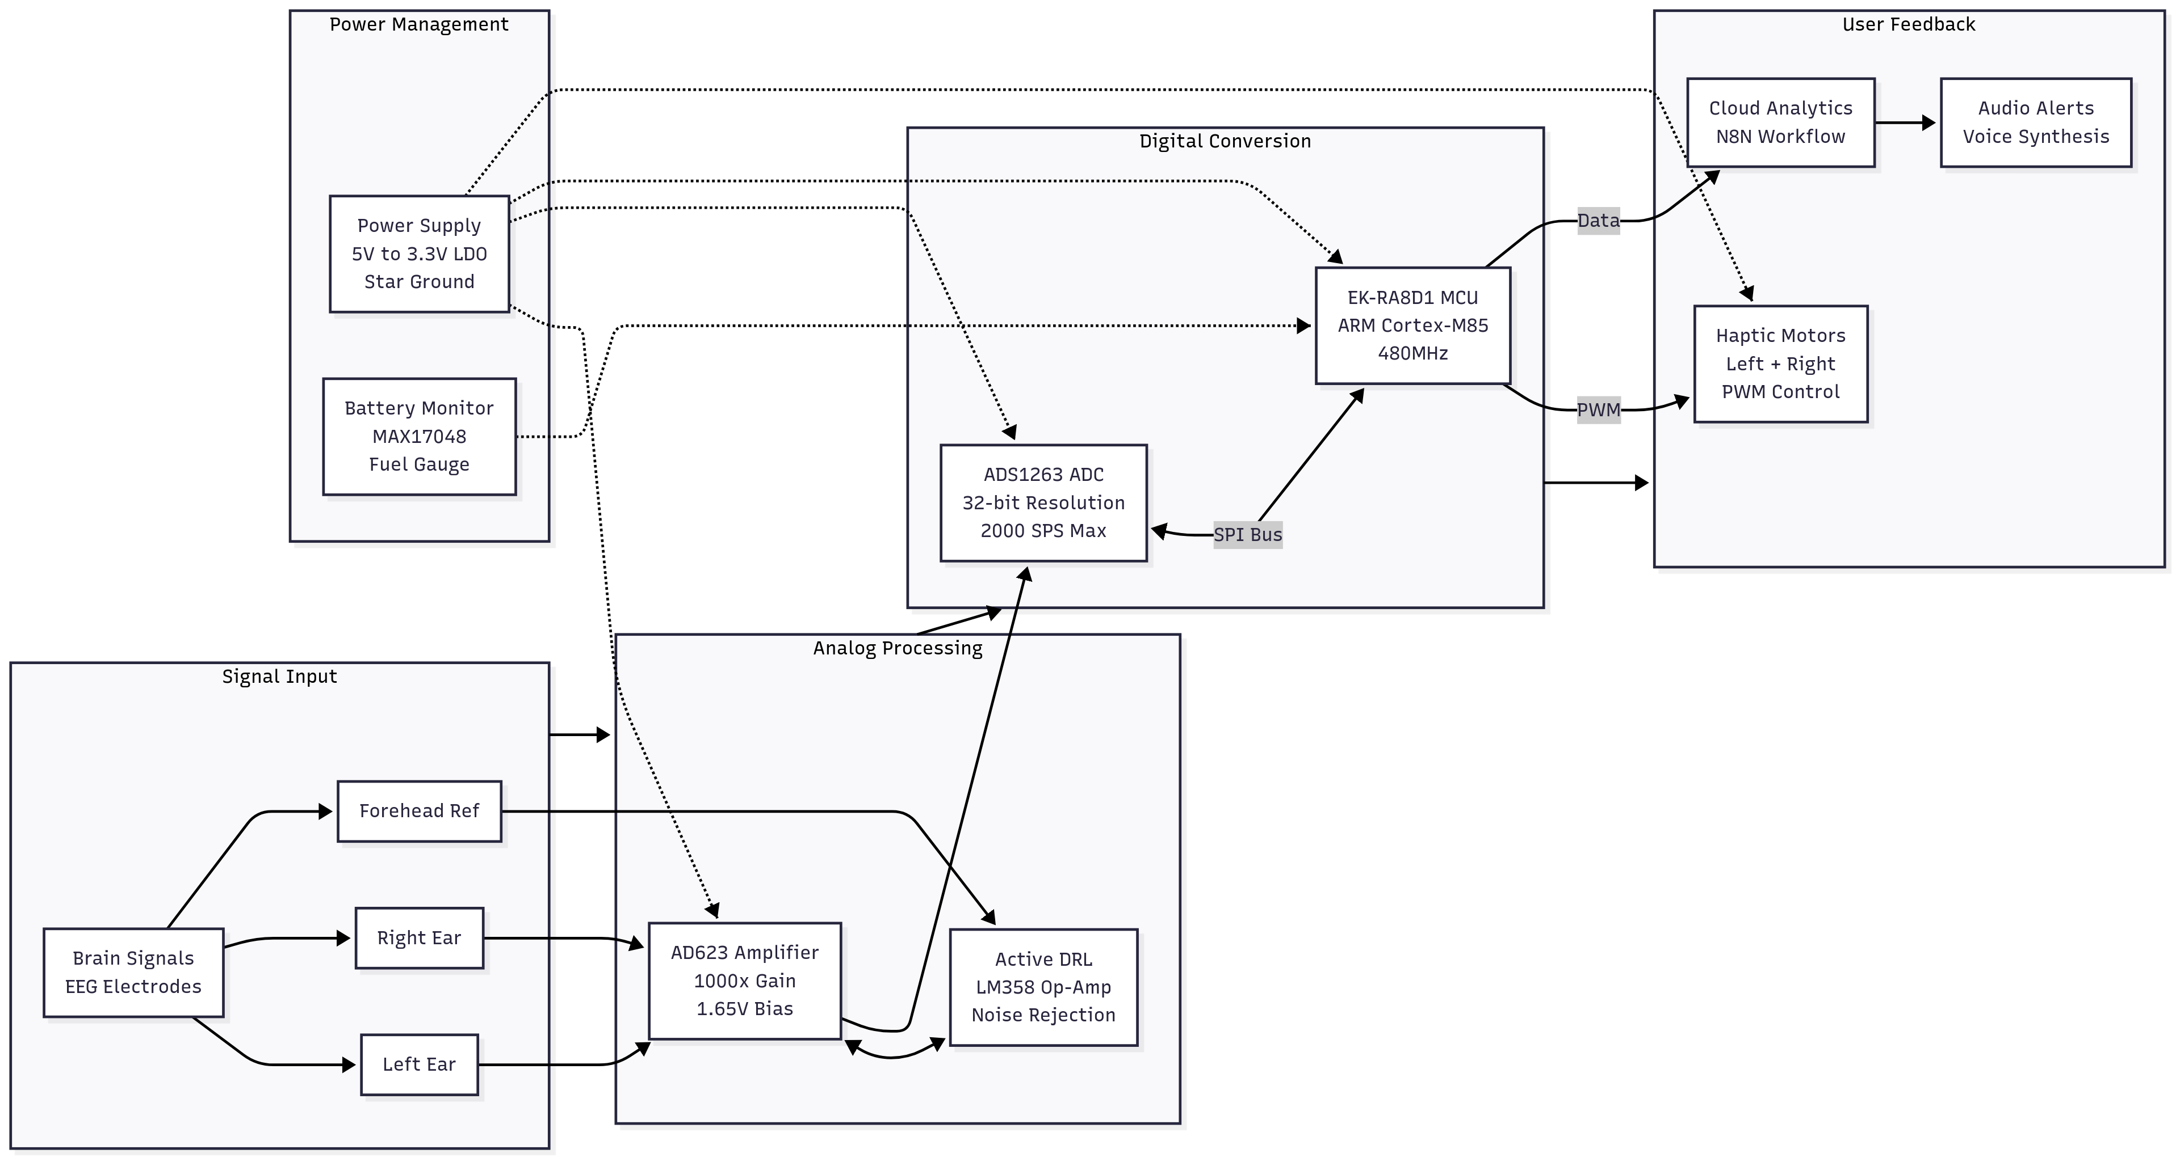

DATA FLOW

- EEG Acquisition: Hardware captures brain signals → Signal processing → AI classification
- Data Transmission: MCU sends JSON payload to N8N webhook every 30 seconds
- Cloud Processing: N8N routes data to appropriate AI agent based on content and context
- Response Generation: AI agent processes data → Generates response → Delivers via TTS/haptic
- Storage: Session data stored in MongoDB.

PRE-REQUISITIES

1) Hardware Requirements
- Renesas EK-RA8D1 Evaluation Kit (ARM Cortex-M85 @ 480MHz)
- ADS1263 32-bit ADC for EEG signal acquisition
- Dry EEG electrodes (2 channels minimum) and ECG/EEG Reference Electrode
- Vibration motors (2x) for haptic feedback
- Ethernet connection for communication to n8n webhook
- ADS623 Instrumentation Amplifier
- Custom Breadboard Circuit with all the connections (check the Hardware Documentation)

2) Software Requirements
- Docker Desktop v4.40 or higher (Use the latest for the best results).
- n8n (self-hosted)
- MongoDB (Atlas or local installation)
- Renesas e² studio IDE
- FSP (Flexible Software Package) v5.1.0 or later
- μT-Kernel 3.0 RTOS
3) Network Requirements
- Local network access (Wi-Fi or Ethernet)
- Internet connectivity for API services
- Port 5678 accessible for N8N webhooks

n8n WORKFLOW SETUP

Step 1: Install Docker Desktop
Go to the link https://docs.docker.com/engine/install/ and install according to your OS (Ubuntu, Debian, Windows,etc).
Step 2 : Installing n8n
- Open the terminal in Docker Desktop (bottom right)
- Run the command : docker pull docker.n8n.io/n8nio/n8n:latest
- The image that is created will have an ID, copy it.
- Now run this command:
docker run -d \
--name <your_wish_name>
-p 5678:5678
-e N8N_BASIC_AUTH_ACTIVE=true\
-v ~/n8n-data:/home/node/.n8n\
--restart unless -stopped
<paste_the_copied_image_id>
[NOTE : The command sometimes might not run due to indentation errors or so, please refine those errors accordingly. The command remains the same.]
- Create an account via your G-mail ID.
Whenever n8n is locally hosted, the user gets an option to activate a liscence key. As soon as the account is created the user shall get an e-mail from n8n regarding the same. The user has to activate the license key via the email to access almost all functionalities of the n8n software.
Step 3 : Importing the workflow
  - Get the .json file from the link https://github.com/Rishi8520/S.H.R.A.V.Y.A/tree/main/n8n-server/n8n_Workflows
Step 4 : Configure API Keys
  - OpenRouter API (AI Language Model)
- Sign Up
  - Go to https://openrouter.ai
  - Create account and verify email
- Get API Key
  - Go to Keys section
  - Create new API key
  - Copy key for N8N configuration
- Configure in N8N
  - Find "OpenRouter Chat Model" node
  - Add credentials with your API key
  - Model: mistralai/mistral-small-2.3-24b-instruct:free or any other free model
- Deepgram API (Speech-to-Text)
- Create Account
  - Go to https://deepgram.com
  - Sign up for developer account
  - Get $200 free credits
- Generate API Key
  - Go to API Keys in dashboard
  - Create new key with speech-to-text permissions
  - Copy key
- Configure in N8N
  - Find "SHRAVYA STT" HTTP Request node
  - Update Authorization header: Token YOUR_DEEPGRAM_KEY
  - URL: https://api.deepgram.com/v1/listen

- Unreal Speech API (Text-to-Speech)
- Sign Up
  - Go to https://unrealspeech.com
  - Create account (500,000 free characters)
- Get API Key
  - Go to API section in dashboard
  - Copy your API key
- Configure in N8N
  - Find "SHRAVYA Voice Synthesis" HTTP Request node
  - Update Authorization header: Bearer YOUR_UNREAL_SPEECH_KEY
  - URL: https://api.v8.unrealspeech.com/stream

- Gmail API (For Emergency Contacts)
1) Go to Google Cloud Console → APIs & Services
2) Search for Gmail in the search bar under the same section ie APIs & Services.
3) Click on the “Gmail API” and enable it
4) Set up a Oauth 2.0 Client ID :
a) In the Enabled APIs & Services page there would be an option “Gmail API”, click on that.
b) Choose the option “Credentials” from the left sidebar.
c) Click on “+ Create Credential” → Choose Auth Client ID → Application Type = Web Application → Name it (according to user’s wish) → Authorised redirect URIs paste this: http://localhost:5678/rest/oauth2-credential/callback → Click on Create
[NOTE – Please copy the Client ID and Client Secret and keep for your reference to avoid any further inconveniences]
d) Click on Audience in the left sidebar. Under the Test Users → Add Users → Add the email/Gmail Id which shall be the emergency contact and save it. [NOTE – The same id shall be mentioned in the n8n Gmail node]
e) Now in n8n create a credential for Gmail Account. You can do this outside the workflow or in the workflow itself. Fields to be entered:
    - OAuth Redirect URL : http://localhost:5678/rest/oauth2-credential/callback
    - Client ID : Copy paste the same client id that you just created in the previous step. This would be there in the OAuth 2.0 Client ID → Your created Web Application ID (click it) → Under the “Additional Information” section the client id must be mentioned.
    - Client Secret → Copy and Paste the previously copied Client Secret in here.
    - Connect your account by signing in and provide the permissions “Read Compose and Send Emails from your Gmail account” & “View you email messages when you interact with the add-on”.
[NOTE – If a pop-up appears mentioning that Google hasn’t verified this app, please do not worry, your system and the google account shall remain safe. Proceed by choosing “Continue”.]
    - The Connection is Successful!
- MongoDB
1) Atlas Administration API Keys
Purpose: Manage clusters, users, and database configuration programmatically

Step 1: Access API Keys Section
- Login to MongoDB Atlas: https://cloud.mongodb.com
- Select your organization and create a cluster
- Click on "Access Manager" in left sidebar
- Navigate to "API Keys" tab

Step 2: Create Organization API Key
1. Click "Create API Key"
2. Enter Description: "SHRAVYA Project API Access"
3. Select Permissions:
- Organization Project Creator (for full access)
- Organization Read Only (for monitoring)
- Organization Owner (for complete control)
4. Click "Next"

Step 3: Configure Access List
1. Add IP Addresses that can use this API key:
- Your development machine IP
- Server IP where N8N runs
- 0.0.0.0/0 (for testing - NOT recommended for production)
2. Click "Done"

Step 4: Copy Credentials
Public Key: [COPY AND SAVE - shown only once]
Private Key: [COPY AND SAVE - shown only once]

Step 5 – Enter the details into n8n mongoDB credential
- Configuration type – Connection String
- Connection String – Retrieval steps: MongoDB Atlas Dashboard → Clusters Tab → Your created cluster → Connect → Connect to your application, under which select “Drivers”→ Leave everything as it is and copy the connection string under the “Add your connection string into your application code” → Press “Done”.
- Database – Add your database name that you created in mongoDB.
API Configuration Summary
Service | Purpose | Free Tier | Configuration Node
OpenRouter | AI Language Model | Yes (limited) | OpenRouter Chat Model
Deepgram | Speech-to-Text | $200 credits | SHRAVYA STT
Unreal Speech | Text-to-Speech | 500K characters | SHRAVYA Voice Synthesis
MongoDB | EEG Data Storage | 512MB free | Store EEG Session
Gmail | For Emergency Contacta | Yes | Send a message

HARDWARE INTEGRATION

1) Firmware Flash Process
- Setup Development Environment
  - Install Renesas e² studio
  - Import SHRAVYA project
  - Configure FSP packages
- Update Network Settings (Optional/Not Required)
// In communicationN8N.c, update these values for your network:
#define SHRAVYA_IP_ADDR_0 192 // Your MCU IP
#define SHRAVYA_IP_ADDR_1 168
#define SHRAVYA_IP_ADDR_2 1
#define SHRAVYA_IP_ADDR_3 200
#define PC_IP_ADDR_0 192 // Your N8N server IP
#define PC_IP_ADDR_1 168
#define PC_IP_ADDR_2 1
#define PC_IP_ADDR_3 100
[NOTE : If the steps are followed as described above, there’s no need to update any address as n8n would be hosted on prot 5678 itself.]
- Build and Flash
  - Build project in Debug configuration
  - Flash firmware to EK-RA8D1 board

FRONTEND INTERFACE

1) Setup Instructions :
- Save HTML File
  - Save the provided frontendSHRAVYA.html to your local directory
  - Ensure N8N is running on localhost:5678
- Open in Browser
  - Open HTML file in modern web browser
  - Chrome/Firefox recommended for WebRTC voice features
- Interface Components
Control Buttons:
  - Start EEG Monitoring - Initiates data collection session
  - Stop Monitoring - Ends current session
  - Start Greeting - Test voice synthesis
  - Listen to Command - Record voice command (5 seconds)
- Test Buttons:
  - Test Basic EEG - Sends sample EEG data for testing
  - Test High Stress - Simulates high stress scenario
  - Test Perfect Focus - Simulates optimal focus state
  - Clear Log - Clears activity and response logs
- Real-time Displays:
  - Wellness Score (0-10 scale)
  - Focus Level (real-time from EEG)
  - Stress Level (real-time from EEG)
  - Calm Level (real-time from EEG)
  - Flow State (peak performance indicator)
  - Connection Status (hardware connectivity)
  - Sampling Rate (EEG acquisition rate)
Frontend Configuration
JavaScript Configuration (matches C code):
const CONFIG = {
voiceWebhook: 'http://localhost:5678/webhook/shravya-voice',
eegWebhook: 'http://localhost:5678/webhook/shravya-eeg-stream',
updateInterval: 30000, // 30 seconds (matches C TRANSMISSION_INTERVAL_S)
recordingDuration: 5000 // 5 seconds for voice commands
};
Testing Frontend Integration
- Test Voice Commands
  - Click "Start Greeting" - should hear SHRAVYA introduce herself
  - Click "Listen to Command" - speak "user mode" - should get response
  - Check browser console for any errors
- Test EEG Data Flow
  - Click "Start EEG Monitoring" - establishes session
  - Click test buttons to send sample data
  - Verify data appears in real-time displays
  - Check N8N workflow execution logs
- Monitor Activity Logs
  - Activity Log shows system status and connections
  - Response Log shows AI agent responses
  - Audio player shows generated voice responses
TESTING & VALIDATION
System Integration Test
Test 1: End-to-End EEG Flow
- Start N8N workflow
- Open frontend interface
- Click "Start EEG Monitoring"
- Flash hardware with SHRAVYA firmware
- Verify EEG data appears in frontend
- Check MongoDB for stored sessions
- Test AI agent responses
Test 2: Voice Command Processing
- Click "Start Greeting" - verify TTS works
- Click "Listen to Command" and say "user mode"
- Verify voice recognition and AI response
- Test different voice commands:
  - "user mode" → switches to wellness companion
  - "developer mode" → requires authentication
  - General questions → conversational responses
Test 3: Multi-Agent System
- Send EEG data with high stress (>7.0)
  - Should trigger EEG Monitor agent
  - Should provide wellness intervention
- Send voice command "user mode"
  - Should trigger Voice Command agent
  - Should provide warm greeting
- Send developer authentication
  - Should trigger Developer agent
  - Should provide technical assistance

PERFORMANCE VALIDATION

Latency Testing:
- EEG data processing: Target <100ms from MCU to N8N response
- Voice processing: Target <5-10 seconds from recording to TTS response (depending upon the voice command)
- AI agent routing: Target <2s decision time
Accuracy Testing:
- EEG cognitive states: Validate against known mental states
- Voice recognition: Test with different accents and background noise
- AI agent routing: Verify correct agent selection based on input

DEBUG MODE

Enable Detailed Logging:
- In N8N workflow, enable "Execute Once" on debug nodes
- Check N8N execution logs for detailed error messages
- Enable UART debug output in firmware:
Log Analysis:
- N8N logs: Check workflow execution tab for node-by-node status
- Browser logs: Open Developer Tools → Console for frontend errors
- Hardware logs: Monitor UART output for MCU debug messages

N8N Workflow Optimization:
- Enable workflow caching for frequently accessed data
- Implement connection pooling for database operations
- Use async processing for non-critical operations
- Optimize memory usage with buffer limits

SECURITY CONSIDERATIONS

API Security:
- Rotate API keys regularly
- Implement rate limiting
- Use environment variables for secrets
- Enable/Disable CORS restrictions according to your requirement
Network Security:
- Use HTTPS for all external communications
- Implement VPN for hardware connections
- Firewall configuration for restricted access
- Regular security updates

CONCLUSION

This documentation provides a comprehensive guide for setting up and configuring the SHRAVYA cognitive AI assistant system. The integration of real-time EEG processing, intelligent AI agents, and cloud-based workflow automation creates a powerful platform for cognitive wellness monitoring and intervention.
For additional support:
- Check the GitHub repository for code updates
- Review N8N community documentation
- Contact – E-mail : rishiraj.mitblr2022@learner.manipal.edu
The SHRAVYA system represents a significant advancement in wearable cognitive monitoring technology, combining edge AI processing with cloud intelligence to provide real-time insights and interventions for optimal brain health and performance.

